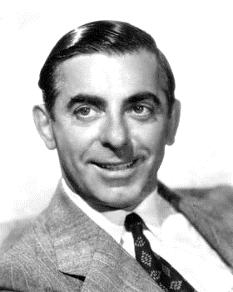
The Mixed Nuts
Set GG Last revised on 2016.03.06

GG01-The Song Is You(KVF).pdf
GG01-The Song Is You(KVM).pdf
GG02-After The Ball_The Band Played On(KVF).2015.02.01.pdf
GG02-After The Ball_The Band Played On(KVM).2015.02.01.pdf
GG03-Blue Bayou(KVD).2015.10.26.pdf
GG04-Back In Your Own Backyard(KVF).2015.02.01.pdf
GG04-Back In Your Own Backyard(KVM).2015.02.01.pdf
GG05-Can't Help Falling In Love(KVF).pdf
GG05-Can't Help Falling In Love(KVM).pdf
GG06-Praha Polka(K).2015.05.17.pdf
GG07-Once In A While(KVF).2015.05.17.pdf
GG07-Once In A While(KVM).2015.05.17.pdf
GG08-Bei Mir Bist Du Schon(KVF).2015.02.01.pdf
GG08-Bei Mir Bist Du Schon(KVM).2015.02.01.pdf
GG09-How Ya Gonna Keep 'Em Down On The Farm(KVF).2015.10.26.pdf
GG09-How Ya Gonna Keep 'Em Down On The Farm(KVM).2015.10.26.pdf
GG10-Ma, He's Making Eyes At Me(KVF).2016.03.06.pdf
GG10-Ma, He's Making Eyes At Me(KVM).2016.03.06.pdf
GG11-If You Knew Susie(KV).2015.05.17.pdf
GG12-Slowpoke(KVF).2016.03.06.pdf
GG12-Slowpoke(KVM).2016.03.06.pdf
GG13-Great Pretender, The(KVD).2016.03.06.pdf
GG14-You Were Meant For Me(KVF).2015.02.16.pdf
GG14-You Were Meant For Me(KVM).2015.02.16.pdf
GG15-How Much Is That Doggie In The Window(KVF).2015.05.17.pdf

GG15-How Much Is That Doggie In The Window(KVM).2015.05.17.pdf
GG16-Some Enchanted Evening(KVF).2015.10.26.pdf
GG16-Some Enchanted Evening(KVM).2015.10.26.pdf
GG17-South Rampart Street Parade(K).2016.03.06.pdf

